
Regulation:
A15
Sreenidhi Institute of Science and Technology
(An Autonomous Institution)
Code No: 5W104 Date : 27.02.2016

M.Tech. I-Year I-Semester Examinations, Feb/March- 2016 (Regular)
ADVANCED MECHANICS OF SOLIDS (CAD/CAM)

Time: 3 Hours Max.Marks:75

Note: No additional answer sheets will be provided.

Part - A
Max.Marks:25

Answer all QUESTIONS.
- State Maxwell‐Betti Reciprocal Theorem 3M
- Show the shear stress distribution for a channel section of a cantilever beam subjected to transverse load at it’s free end. 3M
- Give the formula for radius of curvature of neutral axis for T section. 3M
- Write the Prandtl equation for torsion of solid sections 3M
- Give the expression for crippling load of a coloumn as an eigen value problem with both ends fixed. 3M
- Define Green’s theorem applicable to fracture mechanics 2M
- State Castigliano’s second theorem 2M
- Discuss Winkler Batch correction factors 2M
- State the Raleigh Ritz method applicable to buckling of column problems. 2M
- Give the formulas for contact stresses for two bodies in line contact subjected to normal loading 2M

Part – B
Max.Marks:50

ANSWER ANY FIVE QUESTIONS. EACH QUESTION CARRIES 10 MARKS.

-- 00 -- 00 –
1. For the system shown in Fig-1, determine the load W necessary to cause a displacement δ in the vertical direction at point O. a is the cross sectional area of each member and l is the length of each member. Use the principle of virtual work. Also find the force in the member OC using Castigliano’s theorem.
A B

W

C

Fig-1

2. For the section shown in Fig-2, find the shear center location distance e
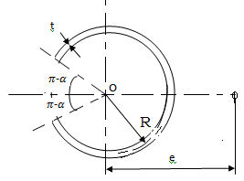
Fig-2
3. A steel railway car wheel may be considered to be approximately a cylinder with a radius of 440 mm. The wheel rolls on a steel rail whose top surface may be considered to be approximately another cylinder with a radius of 300 mm. For the wheel and rail, E=200 GPa and 𝜈=0.29. If the wheel load is 110 KN, determine the maximum principal stress and maximum shear stress. Also determine the vertical displacement of the center of the wheel due to deflections in the region of contact.

4. The cross section shown in Fig-3 is subjected to a torque of 5 KN-m. Estimate the shear stress in each wall. 5 mm

5 mm
150 mm

5 mm110 mm
Fig-3

5 mm
5. For a coloumn with one end built-in and the other end free and carrying an axial
load P, it is assumed that the deflection curve has the form
Y=
Where L is the length of the coloumn and x is measured from the fixed end. Using the energy method, determine the critical load.

6. An edge crack has been detected in a large plate which is to be loaded by a
remote tensile stress (mode-I). In order to determine if this can be done without
risk for fracture, a finite element analysis of the structure was performed; the J-
integral was then calculated along a path as indicated in the Fig-4, and J = 23.83
kN/m was obtained. Assume that LEFM (linear elastic fracture mechanics) can be
used. Will the structure sustain the load?
Data: Plane stress and linear elastic material with
E = 210 GPa ,ν = 0.3 KIc 65 MNm^{–3/2}, a = 100 mm
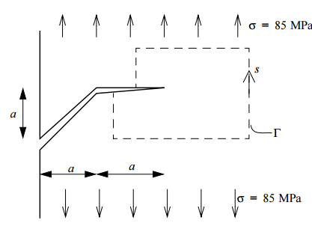
Fig-4
7. Explain the following
a. Asymmetrical bending of a beam having equal-leg angle section.
b. Winkler Bach formula for radial stresses in curved beam of circular section.

